EXPERIMENT NO: 24
Implementation of Disease-Based Diet Recommendation System Using Prolog.
AIM:
To write and execute a Prolog program to suggest a suitable diet system based on different diseases using facts and rules.
PROCEDURE:
- Open SWISH Prolog software.
- Enter the Prolog program in the editor.
- Define different diseases as facts.
- Define suitable diet recommendations for each disease.
- Create rules to identify the disease and suggest the appropriate diet.
- Click the Run button to load the program.
- Enter the required query in the Query box.
- Click Run to execute the program.
- Observe the suggested diet based on the disease.
PROGRAM:
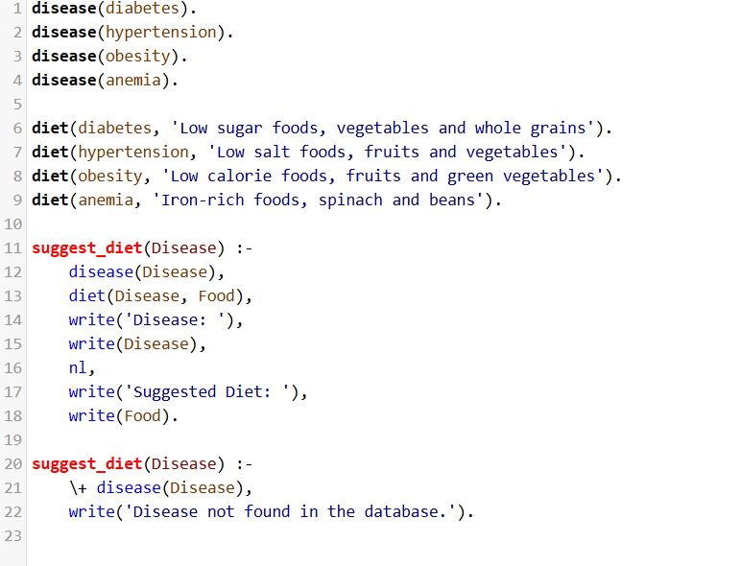
OUTPUT:
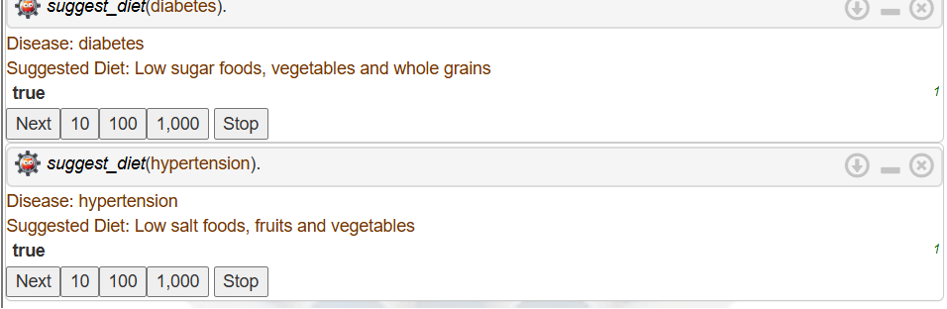

RESULT:
Thus, the Prolog program to suggest a suitable diet system based on different diseases was successfully implemented and executed using facts and rules.

